**Assignment -4**

Digital Marketing

|  |  |
| --- | --- |
| Student Name : | Thiru Selvam T |
| Student Roll Number : | 20URCS049 |
| NM ID : | 97C6EB5A9F3EB30ADCB434840EE2B86C |
| College Name : | AAA College of Engineering and Technology |

**QUESTION:**

**Create email newsletter design using MailChimp or Canva tool. EMAIL NEWSLETTER USING CANVA:**

**Newsletter link:** [**https://luffycrackers.blogspot.com/2023/10/crackers-newsletter.html**](https://luffycrackers.blogspot.com/2023/10/crackers-newsletter.html)

**Newsletter Title: Luffy Crackers**

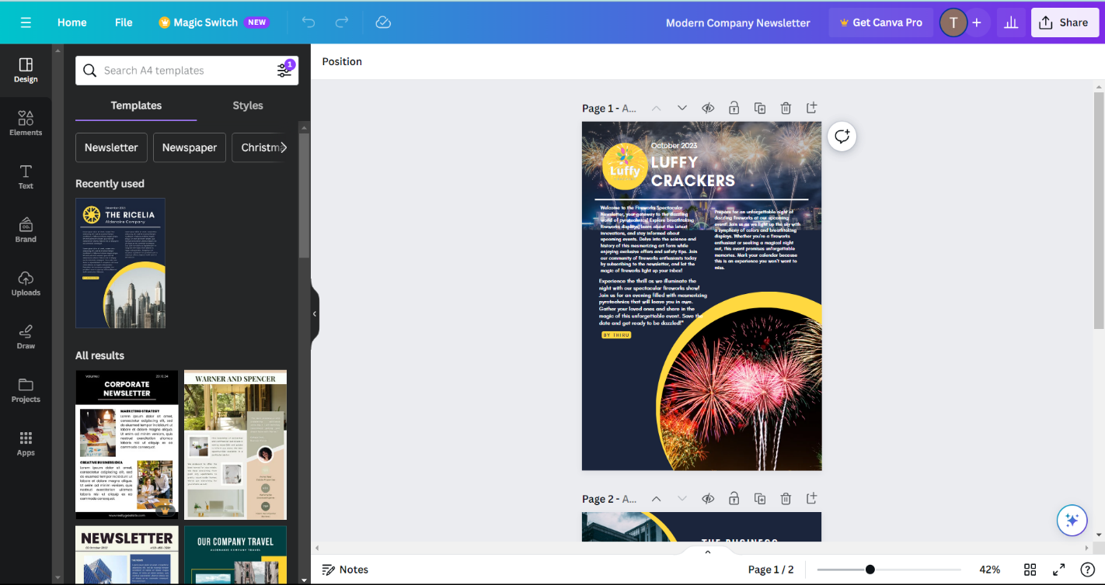

**Poster :**

